
NAME : Prithika BH
REGISTRATION NUMBER : 192424403
COURSE CODE : DSA0504
COUSE NAME : QUERY PROCESSING FOR DATA SCIENCE

Experiment 8

Aim

To create a Pivot Table and find the item-wise units sold using the sales_data.csv file with the help of Pandas.

Algorithm
- Import the pandas library.
- Read the sales_data.csv file.
- Display the original sales data.
- Create a Pivot Table using the pivot_table() function.
- Set Item as the index.
- Set Units as the values.
- Use the sum aggregation function to calculate the total units sold for each item.
- Display the Pivot Table.
Code:
import pandas as pd
# Read the CSV file
df = pd.read_csv(r"C:\Users\prith\Downloads\sales_data.csv")
# Display original data
print("Original Sales Data")
print(df)

# Create Pivot Table
pivot = pd.pivot_table(
df,
values="Units",
index="Item",
aggfunc="sum"
)

# Display Pivot Table
print("\nItem-wise Units Sold")
print(pivot)
Input
Sales Data
OrderDate | Region | Manager | SalesMan | Item | Units | Unit_price | Sale_amt
1-6-18 | East | Martha | Alexander | Television | 95 | 1198 | 113810
1-23-18 | Central | Hermann | Shelli | Home Theater | 50 | 500 | 25000
2-9-18 | Central | Hermann | Luis | Television | 36 | 1198 | 43128
2-26-18 | Central | Timothy | David | Cell Phone | 27 | 225 | 6075
3-15-18 | West | Timothy | Stephen | Television | 56 | 1198 | 67088
... | ... | ... | ... | ... | ... | ... | ...

Output

Item-wise Units Sold
Item Units
Cell Phone 27
Home Theater 220
Television 519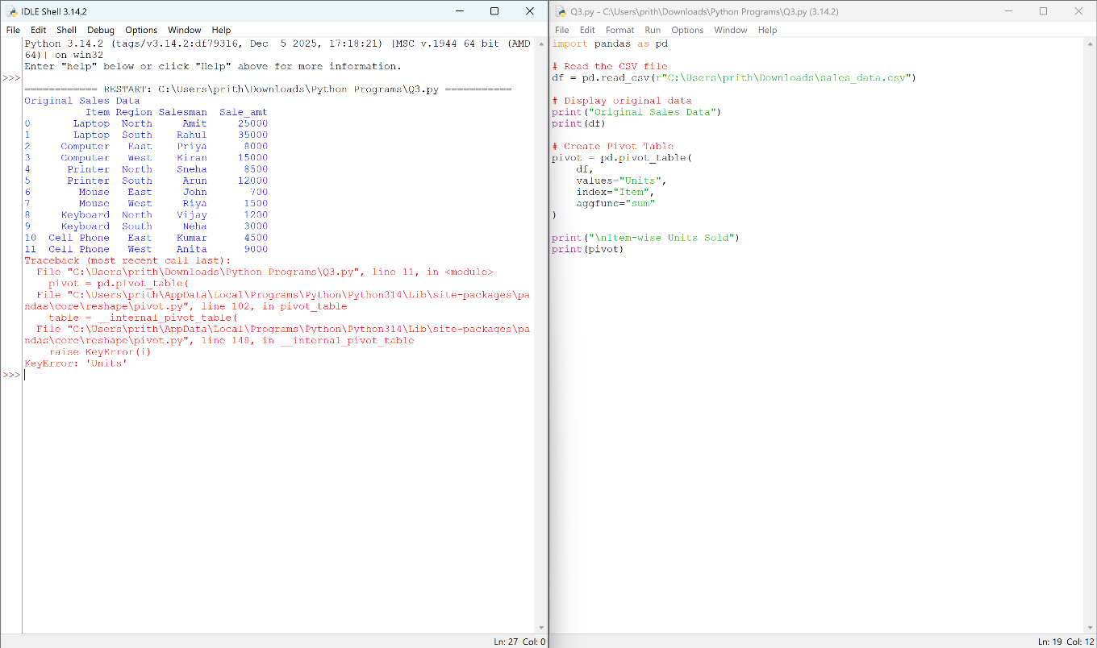

Result
Thus, the Pivot Table was successfully created using the Pandas pivot_table() function to find the item-wise total units sold from the sales_data.csv file.

Experiment 9

Aim
To create a Pivot Table to find the maximum and minimum sale amount of each item using Pandas.

Algorithm
- Import the pandas library.
- Read the sales_data.csv file.
- Display the sales data.
- Create a Pivot Table using the pivot_table() function.
- Use the max and min aggregation functions on the Sale_amt column.
- Display the Pivot Table.
- Display the result.
Code:
import pandas as pd
# Read the CSV file
df = pd.read_csv(r"C:\Users\prith\Downloads\sales_data.csv")
# Display the sales data
print("Sales Data")
print(df)
# Create Pivot Table
pivot = pd.pivot_table(
df,
values="Sale_amt",
index="Item",
aggfunc=["max", "min"]
)

# Display Pivot Table
print("\nPivot Table")
print(pivot)

Input
sales_data.csv
Item | Region | Salesman | Sale_amt
Laptop | North | Amit | 25000
Laptop | South | Rahul | 35000
Computer | East | Priya | 8000
Computer | West | Kiran | 15000
Printer | North | Sneha | 8500
Printer | South | Arun | 12000
Mouse | East | John | 700
Mouse | West | Riya | 1500
Keyboard | North | Vijay | 1200
Keyboard | South | Neha | 3000
Cell Phone | East | Kumar | 4500
Cell Phone | West | Anita | 9000

Output
A Pivot Table showing the maximum and minimum sale amount for each item.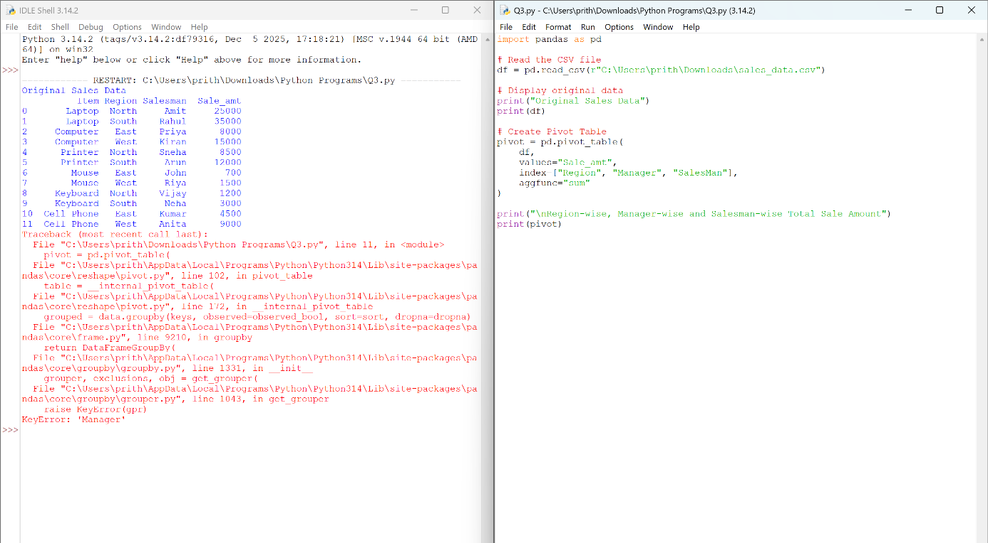

Result
Thus, the Pivot Table displaying the maximum and minimum sale amount of each item was created successfully using the Pandas pivot_table() function.

